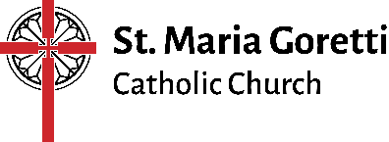
Student Name: _______________________________________
Catholic Church Scavenger Hunt
Go to our church, St. Maria Goretti, and locate the 6 items below. Discuss each with your student and then have him/her answer the questions. Spend a few minutes in prayer together before leaving the church!

- The Baptismal Font – every time we make the sign of the cross with holy water that we are reminded of our baptism
  - Describe the baptismal font.

  - Do you remember your baptism? If so, what do you remember and if not, what do your parents remember about that day?
  - What does water symbolize in baptism?
  - Baptism is the first sacrament you receive. What happens to the soul when one is baptized?

- The Holy Oils
  - What sacraments use these oils?

  - Why do you think we call them “holy”?

- Stations of the Cross
  - Describe our stations of the cross.
  - What story do they tell?
  - Which is your favorite and why?

- Crucifix
  - Where is the crucifix located?
  - Describe the crucifix.
  - Why is the crucifix so important to the Christian life?

- Tabernacle – it is towards the tabernacle that we genuflect upon entering the pew
  - Where is the tabernacle located?
  - What do you think it is made of?
  - Who is kept inside the tabernacle?
  - Why do you think it is kept locked?

  - What does the red lit candle tell us?

- The Confessional – take a peek inside!
  - What do you see in the confessional?

  - Who is present and acting through the priest in the Sacrament of Reconciliation?

  - What 3 things does the Sacrament of Reconciliation do for us?

Overview
- What do all these items helps us to achieve?

- Will you find all these items in all Catholic churches?

- Which part is your favorite and why?

